Mifepristone (Cas No 84371-65-3)
Taj Active Pharmaceuticals Ingredients |  | www.tajapi.com
 |   Raw Material / Chemicals Index

Molecular Structure
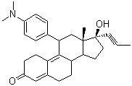
Mifepristone
Molecular Formula C29H35NO2
Molecular Weight 429.60
CAS Number 84371-65-3
Chemical data
Formula C29H35NO2
Mol. mass 429.60 g/mol
Pharmacokinetic data
Bioavailability 69%
Metabolism hepatic
Half life 18 hours
Excretion Fecal: 83%; Renal: 9%

