Montelukast Sodium (Cas No 158966-92-8)
Taj Active Pharmaceuticals Ingredients |  | www.tajapi.com
 |   Raw Material / Chemicals Index
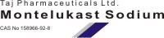
Montelukast Sodium
CAS number 158966-92-8
Structure
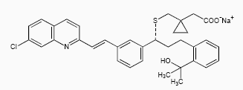
Systematic (IUPAC) name
2-[1-[[(1R)-1-[3-[2-(7-chloroquinolin-2-yl)ethenyl]
phenyl]-3-[2-(2-hydroxypropan-2-yl)phenyl]propyl]
sulfanylmethyl]cyclopropyl]acetic acid
Identifiers
ATC code R03DC03
PubChem 60951
DrugBank APRD00434
Chemical data
Formula C35H36ClNO3S
Mol. mass 586.184 g/mol
SMILES eMolecules & PubChem
Pharmacokinetic data
Bioavailability 63% to 73%
Protein binding 99%
Metabolism Hepatic (CYP3A4 and CYP2C9-mediated)
Half life 2.7-5.5 hours
Excretion Biliary

