Morphine Hcl (Cas No 52-26-6)
Taj Active Pharmaceuticals Ingredients |  | www.tajapi.com
 |   Raw Material / Chemicals Index

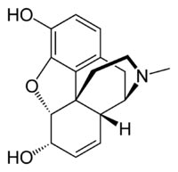
Morphine HCl
CAS number 57-27-2
64-31-3 (neutral sulfate),
52-26-6 (hydrochloride)
Chemical data
Formula C17H19NO3
Mol. mass 285.34
Pharmacokinetic data
Bioavailability ~25% (oral); 100% (IV);
Protein binding 30–40%
Metabolism Hepatic 90%
Half life 2–3 h
Excretion Renal 90%, biliary 10%

