Moxifloxacin Hcl (Cas No 186826-86-8)
Taj Active Pharmaceuticals Ingredients |  | www.tajapi.com
 |   Raw Material / Chemicals Index
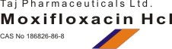
Moxifloxacin HCl
CAS No.: 186826-86-8
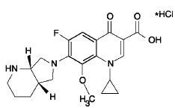
Systematic (IUPAC) name
1-cyclopropyl-7-[(1S,6S)-2,8-diazabicyclo
[4.3.0]non-8-yl]-6-fluoro-8-methoxy-4-oxo- quinoline-3-carboxylic acid
Identifiers
ATC code J01MA14
PubChem 152946
DrugBank APRD00281
ChemSpider 134802
Chemical data
Formula C21H24FN3O4
Mol. mass 401.431 g/mol
SMILES eMolecules & PubChem
Pharmacokinetic data
Bioavailability 86 to 92%
Protein binding 30 to 50%
Metabolism Glucuronide and sulfate conjugation
Cytochrome P450 system not involved
Half life 12 hours
Excretion hepatic
Therapeutic considerations
Pregnancy cat.
Prescription Only
Routes Oral, IV, local (eyedrops)

