Naratriptan (Cas No 121679-13-8)
Taj Active Pharmaceuticals Ingredients |  | www.tajapi.com
 |   Raw Material / Chemicals Index

Naratriptan
CAS number 121679-13-8
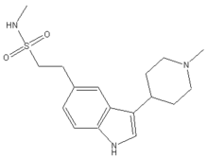
Systematic (IUPAC) name
N-methyl-2-[3-(1-methylpiperidin-4-yl)-1H-indol-5-yl]ethanesulfonamide
Identifiers
CAS number 121679-13-8
ATC code N02CC02
PubChem 4440
DrugBank APRD00220
Chemical data
Formula C17H25N3O2S
Mol. mass 335.465 g/mol
Pharmacokinetic data
Bioavailability 74%
Metabolism Hepatic
Half life 5-8 hours
Excretion Renal
Naratriptan used for the treatment of migraine headaches. Naratriptan is available in 2.5 mg tablets. It is a selective 5-hydroxytryptamine1 receptor subtype agonist. Naratriptan hydrochloride is chemically designated as N-methyl-3-( 1-methyl-4-piperidinyl)-1H-indole-5-ethanesulfonamide.

