Netaglinide (Cas No 105816-04-4)
Taj Active Pharmaceuticals Ingredients |  | www.tajapi.com
 |   Raw Material / Chemicals Index

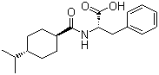
Netaglinide
Molecular Formula C19H27NO3
Molecular Weight 317.43
CAS Registry Number 105816-04-4
IUPAC Name
(2S)-3-phenyl-2-[(4-propan-2-ylcyclohexanecarbonyl)amino]propanoic acid
Properties
Melting point 137-141 ºC

