Norfloxacin (Cas No 70458-96-7)
Taj Active Pharmaceuticals Ingredients |  | www.tajapi.com
 |   Raw Material / Chemicals Index

Norfloxacin
CAS number 70458-96-7
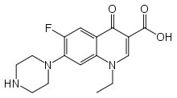
Systematic (IUPAC) name
1-ethyl-6-fluoro-4-oxo-7-piperazin-1-yl-1H-quinoline-
3-carboxylic acid
Identifiers
ATC code J01MA06 S01AX12
PubChem 4539
DrugBank APRD00469
Chemical data
Formula C16H18FN3O3
Mol. mass 319.331 g/mol
Pharmacokinetic data
Bioavailability 30 to 40%
Protein binding 10 to 15%
Metabolism Hepatic
Half life 3 to 4 hours
Excretion Renal and fecal

