Noroxymorphone (Cas No 33522-95-1)
Taj Active Pharmaceuticals Ingredients |  | www.tajapi.com
 |   Raw Material / Chemicals Index
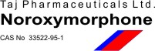
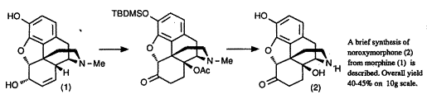
Noroxymorphone
Synonyms: Morphinan-6-one, 4,5-epoxy-314 dihydroxy (5alpha); Noroxymorphone ARS-(FOR R&D USE ONLY); Noroxymorphone Hydrochloride ARS-(FOR R&D USE ONLY)
CAS No.: 33522-95-1
Molecular Weight: 287.30
Chemical Formula: C16H17N04
A brief synthesis of noroxymorphone is described which involves the oxidation of 3-O-tbutyldimethylsilylmorphine by manganese dioxide. The initial product is the corresponding morphinone which is further oxidised to the 14-hydroxymorphinone. After hydrogenation the 7,8-dihydro-14-hydroxymorphinone is acetylated and N-demethylation of the 14-O-acetylated product is achieved using vinyl chloroformate as the reagent. The overall yield from morphine is 40–45%.

