Octreotide Acetate (Cas No 79517-01-4)
Taj Active Pharmaceuticals Ingredients |  | www.tajapi.com
 |   Raw Material / Chemicals Index
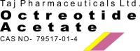
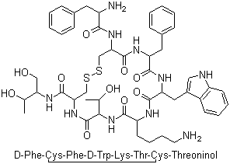
Octreotide Acetate
Molecular Formula C49H66N10O10S2
Molecular Weight 1019.24
CAS Registry Number 79517-01-4
Systematic (IUPAC) name
(4R,7S,10S,13R,16S,19R)-10-(4-aminobutyl)-19-
[[(2R)-2-amino-3-phenyl-propanoyl]amino]-16-
benzyl-N-[(2R,3R)-1,3-dihydroxybutan-2-yl]-7-
(1-hydroxyethyl)-13-(1H-indol-3-ylmethyl)-6,9,12,
15,18-pentaoxo-1,2-dithia-5,8,11,14,17-
pentazacycloicosane-4-carboxamide
Identifiers
CAS number 83150-76-9
ATC code H01CB02
PubChem 54373
DrugBank BTD00088
Chemical data
Formula C49H66N10O10S2
Mol. mass 1019.24 g/mol
Pharmacokinetic data
Bioavailability 100%; I.M: 60% to 63% of subcutaneous dose
Protein binding 65%
Metabolism Hepatic
Half life 1.7-1.9 hours

