Omeprazol (Cas No 73590-58-6)
Taj Active Pharmaceuticals Ingredients |  | www.tajapi.com
 |   Raw Material / Chemicals Index

Omeprazol
CAS number 73590-58-6
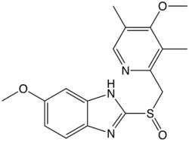
Systematic (IUPAC) name
6-methoxy-2-((4-methoxy-3,5-dimethylpyridin-2-yl) methylsulfinyl)-1H-benzo[d]imidazole
Identifiers
CAS number 73590-58-6
ATC code A02BC01
PubChem 4594
DrugBank APRD00446
ChemSpider 4433
Chemical data
Formula C17H19N3O3S
Mol. mass 345.4 g/mol
SMILES eMolecules & PubChem
Pharmacokinetic data
Bioavailability 35–60%
Metabolism Hepatic (CYP2C19, CYP3A4)
Half life 1 - 1.2 hours
Excretion 80% Renal
20% Faecal
Therapeutic considerations
Pregnancy cat.
B3(AU) C(US)
Routes Oral, IV

