Ondansetron Base (Cas No 116002-70-1)
Taj Active Pharmaceuticals Ingredients |  | www.tajapi.com
 |   Raw Material / Chemicals Index
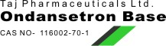
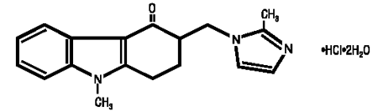
Ondansetron Base
CAS number 116002-70-1
ATC code A04AA01
PubChem 4595
DrugBank APRD00481
ChemSpider 4434
Chemical data
Formula C18H19N3O
Mol. mass 325.9 g/mol
SMILES eMolecules & PubChem
Pharmacokinetic data
Bioavailability ~60%
Protein binding 70%-76%
Metabolism Hepatic (CYP3A4, CYP1A2, CYP2D6)
Half life 5.7 hours
ondansetron hydrochloride (HCl), the racemic form of ondansetron and a selective blocking agent of the serotonin 5-HT3 receptor type. Chemically it is (±) 1, 2, 3, 9-tetrahydro-9-methyl-3-[(2-methyl-1H-imidazol-1- yl)methyl]-4H-carbazol-4-one, monohydrochloride, dihydrate.
The empirical formula is C18H19N3O•HCl•2H2O, representing a molecular weight of 365.9.
Ondansetron HCl is a white to off-white powder that is soluble in water and normal saline.

