Oxcarbazepine (Cas No 28721-07-5)
Taj Active Pharmaceuticals Ingredients |  | www.tajapi.com
 |   Raw Material / Chemicals Index

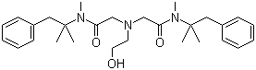
Oxethazaine
Molecular Formula C28H41N3O3
Molecular Weight 467.65
CAS Registry Number 126-27-2
PubChem 4621
Chemical data
Formula C28H41N3O3
Mol. mass 467.643 g/mol
Pharmacokinetic data
Bioavailability ?
Metabolism ?
Half life 1 hour

