Phenobarbital acid (Cas No 50-06-6)
Taj Active Pharmaceuticals Ingredients |  | www.tajapi.com
 |   Raw Material / Chemicals Index
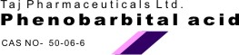
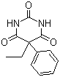
Phenobarbital acid
Molecular Formula C12H12N2O3
Molecular Weight 232.24
CAS Registry Number 50-06-6
Pharmacokinetic data
Bioavailability >95%
Protein binding 20 to 45%
Metabolism Hepatic (mostly CYP2C19)
Half life 53 to 118 hours
Excretion Renal and fecal
Phenobarbital is indicated in the treatment of all types of seizures except absence seizuresPhenobarbital is no less effective at seizure control than more modern drugs such as phenytoin and carbamazepine. It is, however, significantly less well tolerated

