Phenobarbital sodium (Cas No 57-30-7)
Taj Active Pharmaceuticals Ingredients |  | www.tajapi.com
 |   Raw Material / Chemicals Index
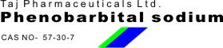
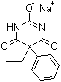
Phenobarbital sodium
Molecular Formula C12H11N2NaO3
Molecular Weight 254.22
CAS Registry Number 57-30-7
Chemistry
Phenobarbital, a barbiturate, occurs as white, glistening, odorless, small crystals or as a white, crystalline powder with a melting point of 174°-178°C and a pKa of 7.41. One gram is soluble in approximately 1000 ml of water, and 10 ml of alcohol. Compared to other barbiturates it has a low lipid solubility.
Phenobarbital sodium occurs as bitter-tasting, white, odorless, flaky crystals or crystalline granules or powder. It is very soluble in water, soluble in alcohol, and freely soluble in propylene glycol. The injectable product has a pH of 8.5-10.5.

