Phenobarbital (Cas No 50-06-6)
Taj Active Pharmaceuticals Ingredients |  | www.tajapi.com
 |   Raw Material / Chemicals Index

Phenobarbital (Cas No 50-06-6)
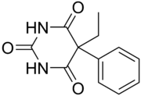
CAS 50-06-6
Molecular Formula: C₁₂H₁₂N₂O₃
Molecular Weight: 232.235280 [g/mol]
H-Bond Donor: 2
H-Bond Acceptor: 3
Description
Biochem/physiol Actions Anesthetic; sedative; hypnotic; anticonvulsant
Properties
Drug control USDEA Schedule IV; Home Office Schedule 3; psychotrope; kontrollierte Droge in India; regulated under CBN India Available from Taj Pharmaceuticals Limited.

Safety
Symbol | GHS06, GHS08
Signal word | Danger
Hazard statements | H301-H317-H351-H360
Precautionary statements | P201-P280-P301 + P310-P308 + P313
Personal Protective Equipment | Eyeshields, Faceshields, full-face particle respirator type N100 (US), Gloves, respirator cartridge type N100 (US), type P1 (EN143) respirator filter, type P3 (EN 143) respirator cartridges
Hazard Codes | T
Risk Statements | 61-25-40-43
Safety Statements | QQW-3453
WGK India | 3
RTECS | INDTPLAPIP9903
Phenobarbital
purum, ≥99.0% (T)
Specifications : USP GRADE
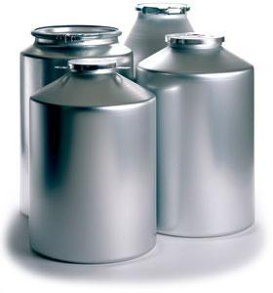*** SAMPLE AVAILABLE

