 | UPDATED ON AUGUST 2009
Taj Pharmaceuticals Chemical List
Fine Chemicals

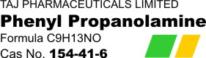 | PRODUCT CODE- PHPNT316
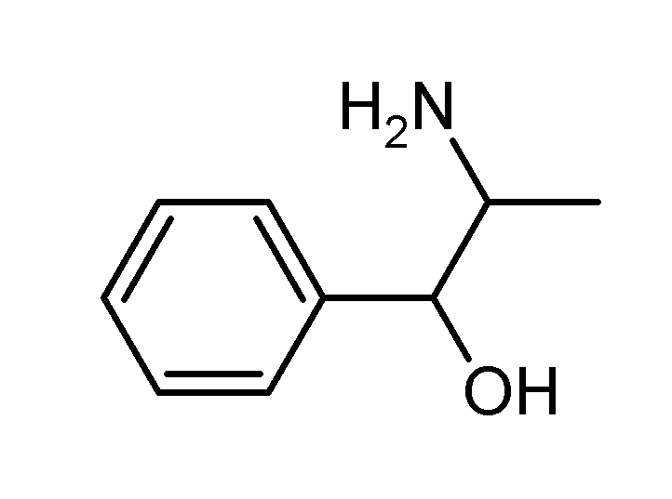
Phenyl Propanolamine BP/USP
Item Number : PH157
CAS Number : 154-41-6
Molecular Formula : C9H13NO.HCl
Molecular Weight : 187.67
Synonyms (1RS,2SR)-2-Amino-1-phenylpropan-1-ol Hydrochloride; (+/-)-Norephedrine Hydrochloride
Phenylpropanolamine is a decongestant. It works by constricting (shrinking) blood vessels (veins and arteries) in your body. Constriction of blood vessels in your sinuses, nose, and chest allows drainage of those areas, which decreases congestion.
Phenylpropanolamine is used to treat the congestion associated with allergies, hay fever, sinus irritation, and the common cold. Phenylpropanolamine also causes a decrease in appetite and is used in some over-the-counter diet aids.
Phenylpropanolamine has been associated with an increased risk of hemorrhagic stroke (bleeding into the brain or into tissue surrounding the brain) in women. Men may also be at risk. Although the risk of hemorrhagic stroke is low, the U.S. Food and Drug Administration (FDA) recommends that consumers not use any products that contain phenylpropanolamine.
Additional Information
DEA scheduled list 1 chemical. Subject to procurement quota requirements
Phenylpropanolamine (PPA; Accutrim, Dexatrim), also knwon as norephedrine and oxyamphetamine, is a psychoactive drug of the phenethylamine and amphetamine chemical classes which is used as a stimulant, decongestant, and anorectic agent.^{[1][2]} It is commonly used in prescription and over-the-counter cough and cold preparations. In veterinary medicine, it is used to control urinary incontinence in dogs under trade names Propalin and Proin.
PPA acts as a potent and selective releasing agent of norepinephrine and epinephrine, or as a norepinephrine releasing agent (NRA). It also acts as a dopamine releasing agent (DRA) to a lesser extent.
INTERACTIONS WITH OTHER DRUGS
In some cases of urinary incontinence, phenylpropanolamine is used in combination with diethylstilbesterol (an estrogen). No harmful drug interactions are expected with this combination.
Phenylpropanolamine should not be used with L-Deprenyl (Anipryl) due to resulting unpredictable fluctuations in blood pressure.
It is recommended that phenylpropanolamine be withdrawn for 2 weeks preceding the use of L-Deprenyl.
An increased risk of hypertension can also occur if phenylpropanolamine is given in conjunction with tricyclic antidepressants (such as amitriptyline), non-steroidal anti-inflammatory drugs (NSAIDs), or amitraz (active ingredient of the Preventic tick control collar and canine Promeris, a flea control product).
Storage Information
LIGHT SENSITIVE: Keep tightly closed in light-resistant containers.
The Food and Drug Administration (FDA) has taken steps to remove phenylpropanolamine from all drug products and has issued a public health advisory concerning phenylpropanolamine hydrochloride. This drug is an ingredient used in many over-the-counter (OTC) and prescription cough and cold medications as a decongestant and in over-the-counter weight loss products. Phenylpropanolamine has been found to increase the risk of hemorrhagic stroke (bleeding into the brain or into tissue surrounding the brain) in women. Men may also be at risk. Although the risk of hemorrhagic stroke is very low, FDA recommends that consumers not use any products that contain phenylpropanolamine.
Summary of Interactions with Vitamins, Herbs, and Foods
In some cases, an herb or supplement may appear in more than one category, which may seem contradictory. For clarification, read the full article for details about the summarized interactions.

Note: These API/ chemicals are designated as those that are used in the manufacture of the controlled substances and are important to the manufacture of the substances. For any (Control Substance) products Import and Export *** subjected to your country government laws /control substance ACT.

Note /Government Notification: N/A
This document plus the full buyer / prescribing information, prepared
for health professionals can be found at:
http://www.tajapi.com
or by contacting the sponsor, Taj Pharmaceuticals Limited., at:
91 022 30601000.
This leaflet was prepared by
Taj Pharmaceuticals Limited,
Mumbai (India).
PRODUCT CODE- PHPNT316
Last revised: 29 August 2009


