Quinine Sulfate (Cas No 130-95-0)
Taj Active Pharmaceuticals Ingredients |  | www.tajapi.com
 |   Raw Material / Chemicals Index
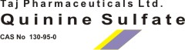
Quinine Sulfate
CAS number 130-95-0
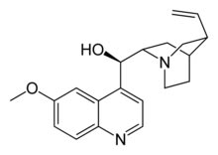
Systematic (IUPAC) name
(R)-(6-methoxyquinolin-4-yl)((2S,4S,8R)- 8-vinylquinuclidin-2-yl)methanol
Identifiers
CAS number 130-95-0
ATC code M09AA01 P01BC01
PubChem 8549
DrugBank APRD00563
ChemSpider 84989
Chemical data
Formula C20H24N2O2
Mol. mass 324.417 g/mol
Physical data
Melt. point 177 °C (351 °F)
Pharmacokinetic data
Bioavailability 76 to 88%
Protein binding ~70%
Metabolism Hepatic (mostly CYP3A4 and CYP2C19-mediated)
Half life ~18 hours
Excretion Renal (20%)

