Raloxifene Hcl (Cas No 82640-04-8)
Taj Active Pharmaceuticals Ingredients |  | www.tajapi.com
 |   Raw Material / Chemicals Index

Molecular Structure
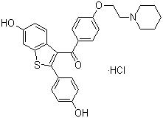
Raloxifene Hcl
Molecular Formula C28H27NO4S.HCl;C28H28ClNO4S
Molecular Weight 510.05
CAS Registry Number 82640-04-8
ATC code G03XC01
PubChem 5035
DrugBank APRD00400
Chemical data
Formula C28H27NO4S
Mol. mass 473.584 g/mol
SMILES eMolecules & PubChem
Pharmacokinetic data
Bioavailability 2%
Protein binding 95%
Metabolism Hepatic glucuronidation
CYP system not involved
Half life 27.7 hours
Excretion Fecal

