Ranitidine Hydrochloride (Cas No 66357-35-5)
Taj Active Pharmaceuticals Ingredients |  | www.tajapi.com
 |   Raw Material / Chemicals Index

Ranitidine Hydrochloride
CAS number 66357-35-5
Structure :
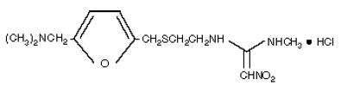
Systematic (IUPAC) name
N-(2-[(5-[(dimethylamino)methyl]furan-2-yl)methylthio]ethyl)-N-methyl-2-nitroethene-1,1-diamine
Identifiers
CAS number 66357-35-5
ATC code A02BA02
PubChem 3001055
DrugBank APRD00254
ChemSpider 571454
Chemical data
Formula C13H22N4O3S
Mol. mass 314.4 g/mol
Pharmacokinetic data
Bioavailability 39 to 88%
Metabolism Hepatic
Half life 2–3 hours
Excretion 30–70% Renal

