Repaglinide (Cas No 135062-02-1)
Taj Active Pharmaceuticals Ingredients |  | www.tajapi.com
 |   Raw Material / Chemicals Index

Molecular Structure
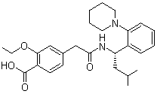
Repaglinide
CAS number 135062-02-1
Formula C27H36N2O4
Mol. mass 452.586 g/mol
ATC code A10BX02
PubChem 65981
DrugBank APRD00439
Pharmacokinetic data
Bioavailability 56% (oral)
Protein binding >98%
Metabolism Hepatic oxidation and glucuronidation (CYP3A4-mediated)
Half life 1 hour
Excretion Fecal (90%) and renal (8%)

