Rivastigmine Tartrate (Cas No 129101-54-8)
Taj Active Pharmaceuticals Ingredients |  | www.tajapi.com
 |   Raw Material / Chemicals Index

Molecular Structure
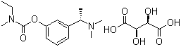
Rivastigmine Tartrate
Molecular Formula C14H22N2O2.C4H6O6
Molecular Weight 400.43
CAS Registry Number 129101-54-8
Pharmacokinetic data
Bioavailability 96%
Protein binding 40%
Metabolism Hepatic, via pseudocholinesterase
Half life 1.5 hours
Excretion Renal, 97%

