Rosiglitazone Maleate (Cas No 155141-29-0)
Taj Active Pharmaceuticals Ingredients |  | www.tajapi.com
 |   Raw Material / Chemicals Index

Rosiglitazone Maleate
CAS number 155141-29-0
Formula Structure :
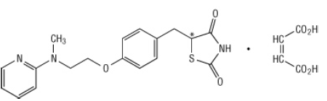
Rosiglitazone Maleate is an oral antidiabetic agent which acts primarily by increasing insulin sensitivity.
Rosiglitazone Maleate improves glycemic control while reducing circulating insulin levels.
Rosiglitazone maleate is not chemically or functionally related to the sulfonylureas, the biguanides, or the alpha-glucosidase inhibitors.
Chemically, rosiglitazone maleate is (±)-5-[[4-[2-(methyl-2-pyridinylamino)ethoxy]phenyl]methyl]-2,4-thiazolidinedione, (Z)-2-butenedioate (1:1) with a molecular weight of 473.52 (357.44 free base).
The molecule has a single chiral center and is present as a racemate.
Due to rapid interconversion, the enantiomers are functionally indistinguishable.
The molecular formula is C18H19N3O3S•C4H4O4. Rosiglitazone maleate is a white to off-white solid with a melting point range of 122 to 123°C.
The pKa values of rosiglitazone maleate are 6.8 and 6.1. It is readily soluble in ethanol and a buffered aqueous solution with pH of 2.3; solubility decreases with increasing pH in the physiological range.
Rosiglitazone is an anti-diabetic drug in the thiazolidinedione class of drugs.

