Sildenafil Citrate (CAS No.: 139755-83-2)
Taj Active Pharmaceuticals Ingredients |  | www.tajapi.com
 |   Raw Material / Chemicals Index
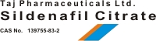
Molecular Structure
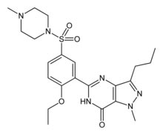
Identifiers
CAS number 139755-83-2
Chemical data
Formula C22H30N6O4S
Mol. mass base: 474.6 g/mol
SMILES eMolecules & PubChem
Pharmacokinetic data
Bioavailability 40%
Metabolism Hepatic (mostly CYP3A4, also CYP2C9)
Half life 3 to 4 hours
Excretion Fecal (80%) and renal (around 13%)
Sildenafil citrate is designated chemically as 1-[[3-(6,7-dihydro-1-methyl-7-oxo-3-propyl-1H- pyrazolo[4,3-d]pyrimidin-5-yl)-4-ethoxyphenyl]sulfonyl]-4-methylpiperazine citrateSildenafil citrate is a white to off-white crystalline powder with a solubility of 3.5 mg/mL in water and a molecular weight of 666.7. VIAGRA (sildenafil citrate) is formulated as blue, film-coated rounded-diamond-shaped tablets equivalent to 25 mg, 50 mg and 100 mg of sildenafil for oral administration. In addition to the active ingredient, sildenafil citrate, each tablet contains the following inactive ingredients: microcrystalline cellulose, anhydrous dibasic calcium phosphate, croscarmellose sodium, magnesium stearate, hypromellose, titanium dioxide, lactose, triacetin.

