Sumatriptan Succinate (Cas No 103628-48-4)
Taj Active Pharmaceuticals Ingredients |  | www.tajapi.com
 |   Raw Material / Chemicals Index

Molecular Structure
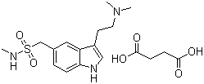
Sumatriptan Succinate
Molecular Formula C14H21N3O2S.C4H6O4
Molecular Weight 413.49
CAS Registry Number 103628-48-4
Pharmacokinetic data
Bioavailability 15% (oral)/ 96% (s.c)
Protein binding 14%-21%
Metabolism MAO
Half life 2.5 hours
Excretion 60% urine; 40% feces

