Tamsulosin Hcl (Cas No 106463-17-6)
Taj Active Pharmaceuticals Ingredients |  | www.tajapi.com
 |   Raw Material / Chemicals Index
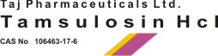
Tamsulosin HCl
CAS number 106463-17-6
Formula Structure :
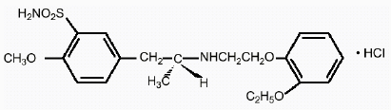
Tamsulosin hydrochloride is an antagonist of alpha1A adrenoceptors in the prostate.
Tamsulosin hydrochloride is (-)-(R)-5-[2-[[2-(o-Ethoxyphenoxy) ethyl]amino]propyl]-2-methoxybenzenesulfonamide, monohydrochloride.
Tamsulosin hydrochloride is a white crystalline powder that melts with decomposition at approximately 230°C.
It is sparingly soluble in water and methanol, slightly soluble in glacial acetic acid and ethanol, and practically insoluble in ether.
The empirical formula of tamsulosin hydrochloride is C20H28N2O5S•HCl.
The molecular weight of tamsulosin hydrochloride is 444.98.
Tamsulosin is approved to treat male urinary symptoms due to BPH, also called an enlarged prostate.
Only your doctor can tell if you have BPH, not a more serious condition like prostate cancer.
Avoid driving or hazardous tasks for 12 hours after your first dose or increase in dose, as a sudden drop in blood pressure may occur, rarely resulting in fainting.

