Tegaserod Maleate (Cas No 189188-57-6)
Taj Active Pharmaceuticals Ingredients |  | www.tajapi.com
 |   Raw Material / Chemicals Index
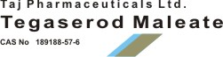
Tegaserod Maleate
CAS number 189188-57-6
Formula Structure :
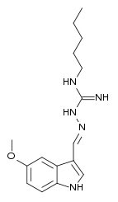
Systematic (IUPAC) name
(2E)-2-[(5-Methoxy-1H-indol-3-yl)methylene]-N-pentylhydrazinecarboximidamide
Identifiers
CAS number 189188-57-6
ATC code A03AE02
PubChem 6918369
DrugBank APRD00096
Chemical data
Formula C16H23N5O
Mol. mass 301.39 g/mol
SMILES eMolecules & PubChem
Pharmacokinetic data
Bioavailability 10%
Protein binding 98%
Metabolism Gastric and hepatic
Half life 11 ± 5 hours
Excretion Fecal and renal
Tegaserod Maleate contain tegaserod as the hydrogen maleate salt.
As the maleate salt, tegaserod is chemically designated as 3-(5-methoxy-1H-indol-3-ylmethylene)-N-pentylcarbazimidamide hydrogen maleate. Its empirical formula is C16H23N5O.C4H4O4.
The molecular weight is 417.47Tegaserod as the maleate salt is a white to off-white crystalline powder and is slightly soluble in ethanol and very slightly soluble in water. Each 1.385 mg of tegaserod as the maleate is equivalent to 1 mg of tegaserod.

