Telmisartan (Cas No 144701-48-4)
Taj Active Pharmaceuticals Ingredients |  | www.tajapi.com
 |   Raw Material / Chemicals Index

Telmisartan
CAS number 144701-48-4
Formula Structure :
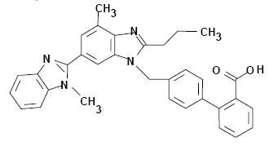
Systematic (IUPAC) name
2-(4-{[4-methyl-6-(1-methyl-1H-1,3-benzodiazol-2-yl)-2-propyl-1H-1,3-benzodiazol-1-yl]methyl}phenyl)benzoic acid
Identifiers
CAS number 144701-48-4
ATC code C09CA07
PubChem 65999
DrugBank APRD01247
Chemical data
Formula C33H30N4O2
Mol. mass 514.617 g/mol
Pharmacokinetic data
Bioavailability 42–100%
Protein binding ≥99.5%
Metabolism Minimal hepatic
Half life 24 hours
Excretion Faecal 97%
Telmisartan is a nonpeptide angiotensin II receptorantntagonist.elmisartan is chemically described as 4'-[(1,4'-dimethyl-2'-propyl [2,6'-bi-1H-benzimidazol]-1'- yl)methyl]-[1,1'-biphenyl]-2-carboxylic acid.
Its empirical formula is C33H30N4O2, its molecular weight is 514.63Telmisartan is a white to slightly yellowish solid.
It is practically insoluble in water and in the pH range of 3 to 9, sparingly soluble in strong acid (except insoluble in hydrochloric acid), and soluble in strong base.

