Terbinafine Hcl (Cas No 78628-80-5)
Taj Active Pharmaceuticals Ingredients |  | www.tajapi.com
 |   Raw Material / Chemicals Index

Terbinafine HCl
CAS number 78628-80-5
Formula Structure :
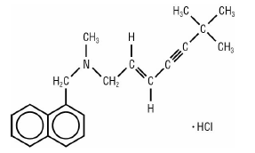
Systematic (IUPAC) name
[(2E)-6,6-dimethylhept-2-en-4-yn-1-yl](methyl)(naphthalen-1-ylmethyl)amine
Identifiers
CAS number 78628-80-5
ATC code D01AE15 D01BA02
PubChem 5402
DrugBank APRD00508
ChemSpider 1266005
Chemical data
Formula C21H25N
Mol. mass 291.43 g/mol
SMILES eMolecules & PubChem
Pharmacokinetic data
Bioavailability Readily absorbed
Protein binding >99%
Metabolism Hepatic
Half life 36 hours
Terbinafine Hydrochloride contain the synthetic allylamine antifungal compound terbinafine hydrochloride.
Chemically, terbinafine hydrochloride is (E)-N-(6,6-dimethyl-2-hepten-4-ynyl)-N-methyl -1- naphthalenemethanamine hydrochloride.
The empirical formula C21H26CIN with a molecular weight of 327.90.
Terbinafine hydrochloride is a white to off-white fine crystalline powder.
It is freely soluble in methanol and methylene chloride, soluble in ethanol, and slightly soluble in water

