Temozolomide (Cas No 85622-93-1)
Taj Active Pharmaceuticals Ingredients |  | www.tajapi.com
 |   Raw Material / Chemicals Index

Molecular Structure
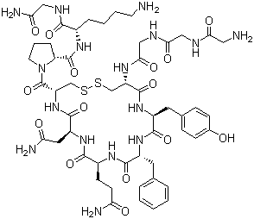
Terlipressin
Molecular Formula C52H74N16O15S2
Molecular Weight 1227.37
CAS Registry Number 14636-12-5
N-(N-(N-Glycylglycyl)glycyl)-8-L-lysinevasopressin; (2S)-1-[(4S,7S,10S,13S,16S,19S)-19-[[2-[[2-[(2-Aminoacetyl)amino]acetyl]amino]acetyl]amino]-13-benzyl-10-(2-carbamoylethyl)-7-(carbamoylmethyl)-16-[(4-hydroxyphenyl)methyl]-6,9,12,15,18-pentaoxo-1,2-dithia-5,8,11,14,17-pentazacycloicosane-4-carbonyl]-N-[(1S)-5-amino-1-(carbamoylmethylcarbamoyl)pentyl]pyrrolidine-2-carboxamide

