Thebaine (Cas No 115-37-7)
Taj Active Pharmaceuticals Ingredients |  | www.tajapi.com
 |   Raw Material / Chemicals Index
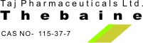
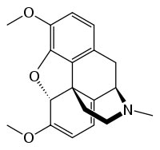
Thebaine
CAS number 115-37-7
Molecular formula C19H21NO3
Molar mass 311.37 g mol−1
Thebaine, a minor constituent of opium, is controlled in Schedule II of the CSA as well as under international law. Although chemically similar to both morphine and codeine, thebaine produces stimulatory rather than depressant effects. Thebaine is not used therapeutically, but is converted into a variety of substances including oxycodone, oxymorphone, nalbuphine, naloxone, naltrexone, and buprenorphine.

