Tiagabine Hcl (Cas No 145821-59-6)
Taj Active Pharmaceuticals Ingredients |  | www.tajapi.com
 |   Raw Material / Chemicals Index

Molecular Structure
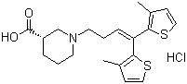
Tiagabine Hcl
Molecular Formula C20H25NO2S2.HCl
Molecular Weight 412.01
CAS Registry Number 145821-59-6
Pharmacokinetic data
Bioavailability 90%
Protein binding 96%
Metabolism Hepatic (CYP450 system)
Half life 7-9 hours
Excretion Fecal and renal

