Venlafaxine (Cas No 93413-69-5)
Taj Active Pharmaceuticals Ingredients |  | www.tajapi.com
 |   Raw Material / Chemicals Index

Venlafaxine
CAS number 93413-69-5
Formula Structure :
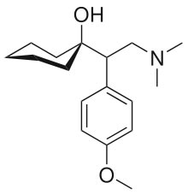
Systematic (IUPAC) name
1-[2-dimethylamino-1-(4-methoxyphenyl)-ethyl]cyclohexanol
Identifiers
CAS number 93413-69-5
ATC code N06AX16
PubChem 5656
DrugBank APRD00125
ChemSpider 56641
Chemical data
Formula C17H27NO2
Mol. mass 277.402 g/mol
SMILES eMolecules & PubChem
Pharmacokinetic data
Bioavailability 45%
Protein binding 27%
Metabolism Hepatic
Half life 5 ± 2 hours (parent compound); 11 ± 2 hours (active metabolite)
Excretion Renal
Venlafaxine is an extended-release capsule for oral administration that contains venlafaxine hydrochloride, a structurally novel antidepressant. It is designated (R/S)-1-[2-(dimethylamino)-1- (4-methoxyphenyl)ethyl] cyclohexanol hydrochloride or (±)-1-[α- [(dimethylamino)methyl]-pmethoxybenzyl] cyclohexanol hydrochloride and has the empirical formula of C17H27NO2 HCl.
Its molecular weight is 313.87.Venlafaxine hydrochloride is a white to off-white crystalline solid with a solubility of 572 mg/mL in water (adjusted to ionic strength of 0.2 M with sodium chloride).
Its octanol : water (0.2 M sodium chloride) partition coefficient is 0.43.

