Voriconazole (Cas No 137234-62-9)
Taj Active Pharmaceuticals Ingredients |  | www.tajapi.com
 |   Raw Material / Chemicals Index
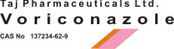
Voriconazole
CAS number 137234-62-9
Formula Structure :
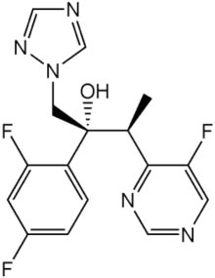
Systematic (IUPAC) name
(2R,3S)-2-(2,4-difluorophenyl)-3- (5-fluoropyrimidin-4-yl)-1- (1H-1,2,4-triazol-1-yl) butan-2- ol
Identifiers
CAS number 137234-62-9
ATC code J02AC03
PubChem 71616
DrugBank APRD00543
Chemical data
Formula C16H14F3N5O
Mol. mass 349.311 g/mol
Pharmacokinetic data
Bioavailability 96%
Protein binding 58%
Metabolism Hepatic cytochrome P450 enzymes CYP2C19, CYP2C9, CYP3A4
Half life Dose-dependent
Excretion ?
Therapeutic considerations
Pregnancy cat. D
Legal status
Prescription only
Routes IV, oral
Voriconazolea Triazole antifungal agent, is available as a lyophilized powder for solution for intravenous infusion, film-coated tablets for oral administration, and as a powder for oral suspension.
Voriconazole is designated chemically as (2R,3S)-2-(2,4-difluorophenyl)-3-(5-fluoro-4- pyrimidinyl)-1-(1H-1,2,4-triazol-1-yl)-2-butanol with an empirical formula of C16H14F3N5O and a molecular weight of 349.3.
Voriconazole drug substance is a white to light-colored powder.

