Ziprasidone Hcl (Cas No 138982-67-9)
Taj Active Pharmaceuticals Ingredients |  | www.tajapi.com
 |   Raw Material / Chemicals Index

Molecular Structure
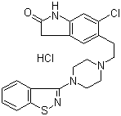
Ziprasidone Hcl
Molecular Formula C21H21ClN4OS.HCl;C21H22Cl2N4OS
Molecular Weight 449.40
CAS Registry Number 138982-67-9
Chemical data
Formula C21H21ClN4OS
Mol. mass 412.936
Pharmacokinetic data
Bioavailability 100% (intramuscular)
60% (orally)
Metabolism hepatic (aldehyde reductase)
Half life 2 - 5 hours
Excretion Urine and feces

