Zolpidem Tartrate (Cas No 99294-93-6)
Taj Active Pharmaceuticals Ingredients |  | www.tajapi.com
 |   Raw Material / Chemicals Index

Molecular Structure
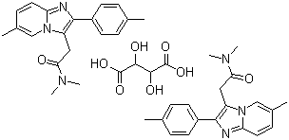
Zolpidem Tartrate
Molecular Formula 2(C19H21N3O).C4H6O6
Molecular Weight 764.88
CAS Registry Number 99294-93-6
ATC code N05CF02
PubChem 5732
DrugBank APRD00095
ChemSpider 5530
Chemical data
Formula C19H21N3O
Mol. mass 307.395 g/mol
SMILES eMolecules & PubChem
Pharmacokinetic data
Bioavailability 70% (oral) 92% bound in plasma
Metabolism Hepatic CYP34A
Half life 2 to 2.6 hours
Excretion 56% renal
34% fecal

