Taj Active Pharmaceuticals Ingredients |  | www.tajapi.com
 |   Raw Material / Chemicals Index
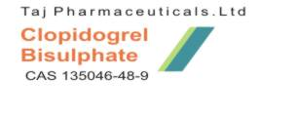
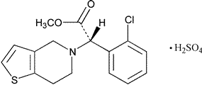
Molecular formula: C16H18ClNO6S2
Molecular weight: 419.03
CAS : 120202-66-6
Specifications:
Appearance: White or off-white powder
[0002]Clopidogrel is the international non-proprietary name of (S)-(+)-Methyl (2-chlorophenyl)-(6,7-dihydro-4H-thieno[3,2-c]pyrid-5-yl)acetate which is having the following structure.
Clopidogrel bisulfate is an anti-platelet drug, that is, a drug that inhibits the ability of platelets to clump together as part of a blood clot. It is similar to ticlopidine (Ticlid) in chemical structure and in the way it works. Unlike ticlopidine, clopidogrel bisulfate does not cause serious reductions of white cells in the blood and, therefore, routine blood testing to determine if the white blood cell count is low is not necessary during treatment. The risk of heart attacks and strokes (which usually are caused by blood clots) is increased in patients with a recent history of stroke or heart attack and patients with peripheral vascular disease.
Clopidogrel bisulfate is a white to off-white powder. It is practically insoluble in water at neutral pH but freely soluble at pH 1. It also dissolves freely in methanol, dissolves sparingly in methylene chloride, and is practically insoluble in ethyl ether. It has a specific optical rotation of about +56°.
Plavix for oral administration is provided as pink, round, biconvex, debossed film-coated tablets containing 97.875 mg of clopidogrel bisulfate which is the molar equivalent of 75 mg of clopidogrel base.
Each tablet contains hydrogenated castor oil, hydroxypropylcellulose, mannitol, microcrystalline cellulose and polyethylene glycol 6000 as inactive ingredients. The pink film coating contains ferric oxide, hypromellose 2910, lactose monohydrate, titanium dioxide and triacetin. The tablets are polished with Carnauba wax.

